ABOUT US

COMPANY HISTORY

The store itself was inaugurated May 16, 1997 by spouses NOEL & POPO ABRAHAN. Popo's family was into hardware business since 1960's. Her grandparents were the owners of then Cosmos Hardware & Lumber lo- cated at Calicanto, Batangas City, now the location of Caedo Commer- cial Center. It was here where she learned this kind of business at a very young age. They then transferred to Manghinao, Bauan, Batangas to put up Bauan Lumber that was managed by her father. Upon graduating from college, her father then opened Bauan Driveline located at S.Ylagan St., Bauan, Batangas. Here, she was the purchaser & marketing officer.

She was trained the hard way, learning the in & out of the construction business. When she got married in 1994, she was very confident to put up their own construction business. The husband & wife team were able to build the trust of their suppliers in just a short span of time. Hand in hand they were able to fulfill their dreams. Indeed, they were great busi- ness partners. Now, they are not just into retail & wholesale business but into planning, designing & building various projects as well.

THE MISSION

To sell different kinds of products to companies and private individuals at the most affordable and reasonable price. To offer various brands & designs that suits the needs of each customer. To build, assemble, fabricate & engineer various civil & struc- tural works with direct supervision & personal expertise.

THE VISION

NATURE & FORM OF BUSINESS

NATURE: Wholesale & retail of complete line of construction, hardware, plumbing, electrical, and fin- ishing materials. Plan, design, build, construct & supervision.

FORM: Single Proprietorshipdashdhasdjhk

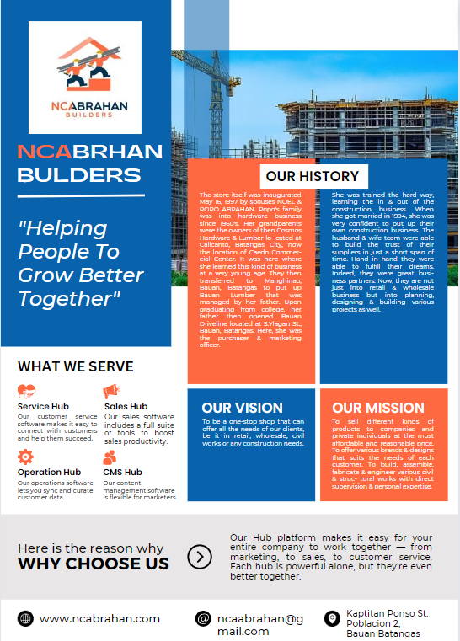

Coco Lumber

Gravel & Sand

Deformed Bars

Gi Corrugated Sheets

Cornice Wood Mouldings

Electrical items

Bathroom Fixtures/ Accessories

Storage Tanks

Cement

Plywood

Paints

Plumbing

Doors

Tiles

Water Heater

Other Hardware Items

﻿

PANASONIC

ROYU

KOTEN

TEKA SINK AND FAUCET

Rosco

MECO

REGINA

AMERILOCK

YALE

SENTRY

MOLDFLEX

BEST TANK

ABC ADHESIVE / GROUT

OMGE

HILTI

MATWOOD

PCW

CAE

VRH

STANLEY

KWIKSET

BORAL

BOSTIK

DORMER

BOYSEN PAINTS

RAIN OR SHINE PAINTS

CORD

PHELPSDODGE

DURAFLEX

FORTUNE CEMENT

POLYDOOR

HCG FIXTURES

ROYAL TERN

EUROTILES

TENZEN TILES

APO VINYL

NELTEX PIPES AND FITTINGS

EMERALD PIPES, FITTINGS AND DOORS

FUSIOTHERM PIPE AND FITTINGS

KRANE BRAND

PHILIPS LIGHTING

FIREFLY

OPPLE LIGHTING

OMNI

Suppliers

EUROTILES INDUSTRIAL CORP.

#2250 CHINO ROCES AVE., PASONG TAMO, MAKATI CITY

MR. ROWEL REYES

(02) 893-1651

STEELHAUS GENERAL MERCHANDISING

UNIT 11-12 RICHLAND BUILDING, DR. A. SANTOS AVE., COR. FILIPINAS AVE. PARANAQUE CITY

MR. JOSEPH RAMBO

(02) 825-6106

NELTEX DEVELOPMENT CO., INC,

PAMPLONA, LAS PINAS, METRO MANILA

MR. LARRY CATAPANG 0922--8047993

KES GENERAL MERCHANDISE

#15 LATUKAN ST. BO. MANRESA, QUEZON CITY MR. JIMMY CHUA

(02) 362-7052

KUYSEN ENTERPRISES

E. RODRIGUEZ AVE. QUEZON CITY MR. ALLAN TAROG 0917-8034341

LS INTERNATIONAL MARKETING

T. ALONZO ST., STA. CRUZ, MANILA

Ms. LEYDEN SY

(02) 254-4096

HOCHENG PHILS. CORP. (HCG)

#1163 CHINO ROCES AVE., MAKATI CITY

MR. MARK FRANCISCO

(02) 895-5683

ALLGEMEINE-BAU-CHEMIE (ABC) PHILS.

FILINVEST, ALABANG, MUNTINLUPA CITY

MR. RUEL TAGAL

(02) 842-6891

POLYDOOR INDUSTRIAL SALES

#60 LEONO ST., BRGY. TANONG, METRO MANILA

MR. GILBERT LIM

(02) 281-4099

FORMOSA CERAMIC TILES CORP. (TENZEN)

MR. VAUGHN BAUTISTA

(02) 416-8803

ACCOMPLISHED PROJECTS

STONYHURSTSOUTHVILLE INTERNATIONAL SCHOOL

GULOD BATANGAS CITY

SUPPLY OF LABOR & MATERIALS FOR THE CONSTRUCTION OF PYLON, FENCE & SIGNAGE SEPT. 20, 2006 Nov. 15, 2006

P 1,400,000.00

JESUS OF NAZARETH HOSPITAL

GULOD BATANGAS CITY

SUPPLY OF LABOR & MATERIALS

FOR THE RE-PAINTING OF WHOLE EXTERIOR WALL APRIL 20, 2007 MAY 25, 2007 P 650,000.00

SAN MIGUEL MILLS, INC.

TABANGAO, BATANGAS

SUPPLY OF LABOR & MATERIALS FOR THE REPLACEMENT OF DILAPIDATED ROOFING AT WAREHOUSE FEB.12, 2008 MARCH 28, 2008 P 821, 847.88

BATANGAS BAY TERMINAL, INC

SAN MIGUEL, BAUAN, BATANGAS SUPPLY OF LABOR & MATERIALS FOR THE INSTALLATION OF WATER SUPPLY LINE MARCH 10, 2009 - APIL 5, 2009 P 493,615.00

BATANGAS BAY TERMINAL, INC

SAN MIGUEL, BAUAN, BATANGAS SUPPLY OF LABOR & MATERIALS FOR THE CONSTRUCTION OF FENCE JULY 10, 2009 SEPT. 5, 2009 P 1, 550,000.00

SAN MIGUEL MILLS, INC MAYBUNGA, PASIG CITY

SUPPLY OF LABOR & MATERIALS FOR THE CONSTRUCTION OF OFFICE ENCLOSURE, WITH

ELECTRICAL & PAINTING WORKS

DEC. 15, 2009 JAN. 10, 2010 P 331,398.80

JESUS OF NAZARETH HOSPITAL GULOD, BATANGAS CITY

SUPPLY OF LABOR & MATERIALS FOR THE REPLACEMENT OF ALL EXISTING FLUORESCENT FIXTURES TO PINLIGHTS WITH ESL BULBS MARCH 13, 2010 - APRIL 4, 2010

P 1,378,000.00

JESUS OF NAZARETH HOSPITAL GULOD, BATANGAS CITY

SUPPLY OF LABOR & MATERIALS FOR THE CONSTRUCTION OF HEARING BOOTH

WITH DRY WALL PARTITION APRIL 16, 2010 JUNE 5, 2010 P 496,611.00

SAN MIGUEL MILLS, INC

BO. BULACAN, MABINI, BATANGAS SUPPLY OF LABOR & MATERIALS FOR THE INSTALLATION OF VINYL TILES MARCH 20,2010 APRIL 4, 2010 P 479,000.00

SAN MIGUEL MILLS, INC

TABANGAO, BATANGAS

SUPPLY OF LABOR & MATERIALS FOR THE RE-PAINTING OF THE EXTERIOR WALL OF WAREHOUSE MAY 4,2010 MAY 25, 2010 P 175,000.00

Page 2

﻿